Supplymentary materials
Metabolomic profiling on plasma reveals potential biomarkers for screening and early diagnosis of gastric cancer and precancerous stages

Lijing Du ^{1,2, #}, Shasha Li ^{2, #}, Xue Xiao ³, Jin Li ⁴, Huizi Jin ¹, Zhaolai Hua ⁵, Juming Ma, ⁴ Xi Wang ^{4*} and Shikai Yan ^{1*}

¹School of Pharmacy, Shanghai Jiao Tong University, Shanghai 200240;
²The Second Clinical College of Guangzhou University of Chinese Medicine, Guangzhou, Guangdong 510006;
³Institute of Traditional Chinese Medicine, Guangdong Pharmaceutical University, Guangzhou, Guangdong 510006;
⁴ Department of Oncology, The 903rd Hospital of PLA, Hangzhou, Zhejiang 310013;
⁵ People’s Hospital of Yangzhong City, Yangzhong, Jiangsu 212200, P.R. China

# Lijing Du and Shasha Li contributed equally to the manuscript
*Correspondence to:
Dr Shi-Kai Yan, School of Pharmacy, Shanghai Jiao Tong University, 800 Dongchuan Road, Shanghai 200240, P.R. China; E-mail: shkyan@sjtu.edu.cn; or Dr Xi Wang, Department of Oncology, The 903rd Hospital of PLA, 14 Lingyi Road, Hangzhou, Zhejiang 310013, P.R. China; E-mail: d.wangxi@hotmail.com
Legends
Fig. S1 ROC characterization of differential metabolites to CSG and EGC. (A) L-Carnitine; (B) L-Proline; (C) Pyruvaldehyde; (D) PC(14:0/18:0); (E) LysoPC(14:0);
(F) Lysinoalanine.
Fig. S2 ROC characterization of differential metabolites to EGC and AGC. (A) L-Proline; (B) L-Valine; (C) Adrenic acid; (D) PC(O-18:0/0:0); (E) LysoPC(20:4(5Z,8Z,11Z,14Z)); (F) Pyruvaldehyde.

Fig. S1
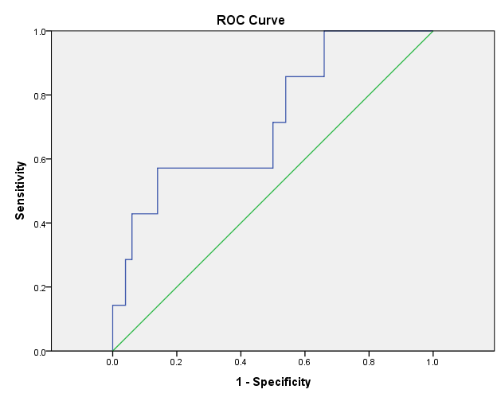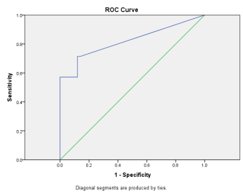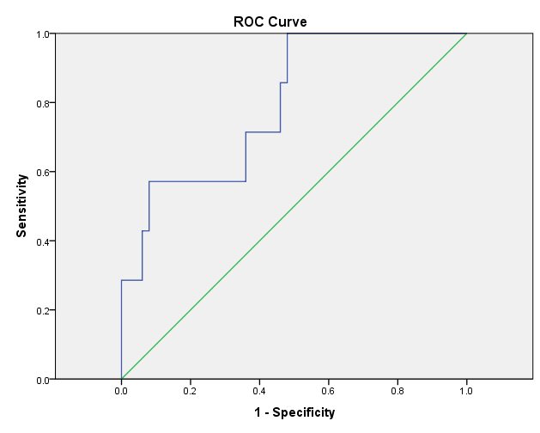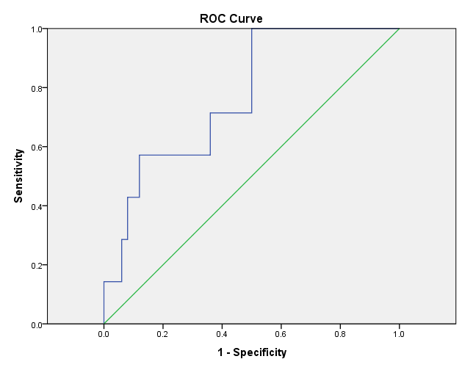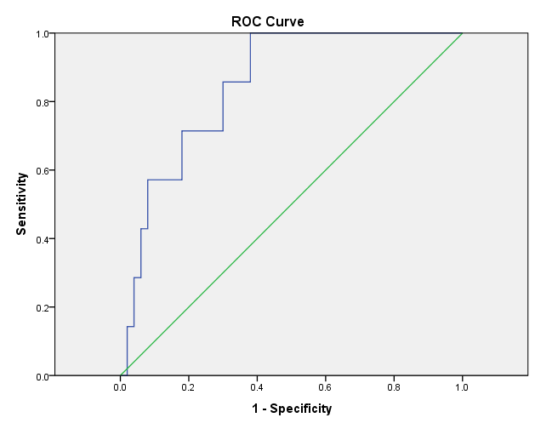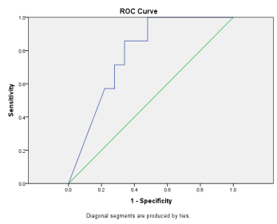
AUC=0.723
AUC=0.769
AUC=0.780
AUC=0.849
AUC=0.794
AUC=0.820

A
B
C
D
E
F

Fig. S2
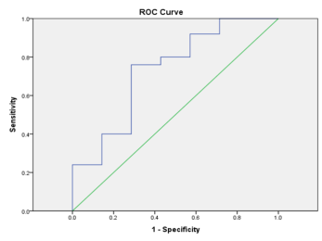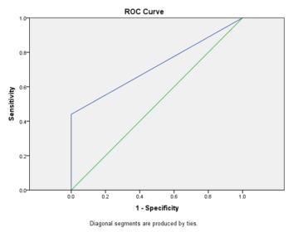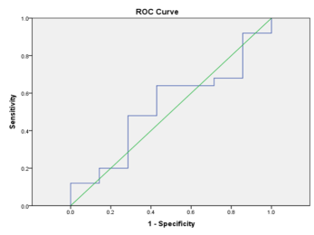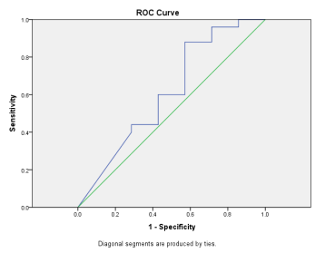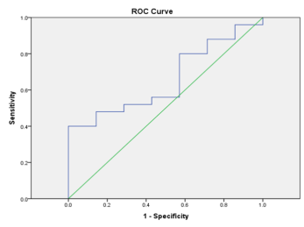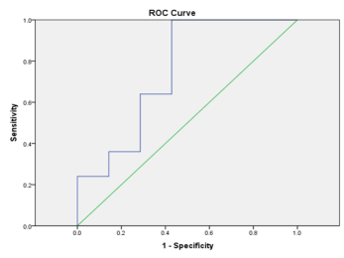
AUC=0.611
AUC=0.731
AUC=0.720
AUC=0.526
AUC=0.749
AUC=0.657
A
E
F
D
C
B

Table S1 Demographic and clinical characteristics of study participants.
 | CSG | EGC | AGC
Gender（Male/ Female） | 14/36 | 6/1 | 19/6
Age（year） | 52.1±7.0 | 66.3±11.9 | 67.0±9.7
TNM ⅠA stage | _ | 7 | _
TNM ⅠB stage | _ | _ | 2
TNM ⅡB stage | _ | _ | 1
TNM ⅢA stage | _ | _ | 9
TNM ⅢB stage | _ | _ | 2
TNM ⅢC stage | _ | _ | 4
TNM Ⅳstage | _ | _ | 7

